
COMSATS UNIVERSITY ISLAMABAD , ATTOCK CAMPUS
SUBMITTED BY :
IRAM SAJJAD
SP22-BSE-023 SUBMITTED TO:
SIR KAMRAN
LAB ASSIGNMENT NO : 02
TITLE: LOGIN AND REGISTRATION FORM

SNIPS:
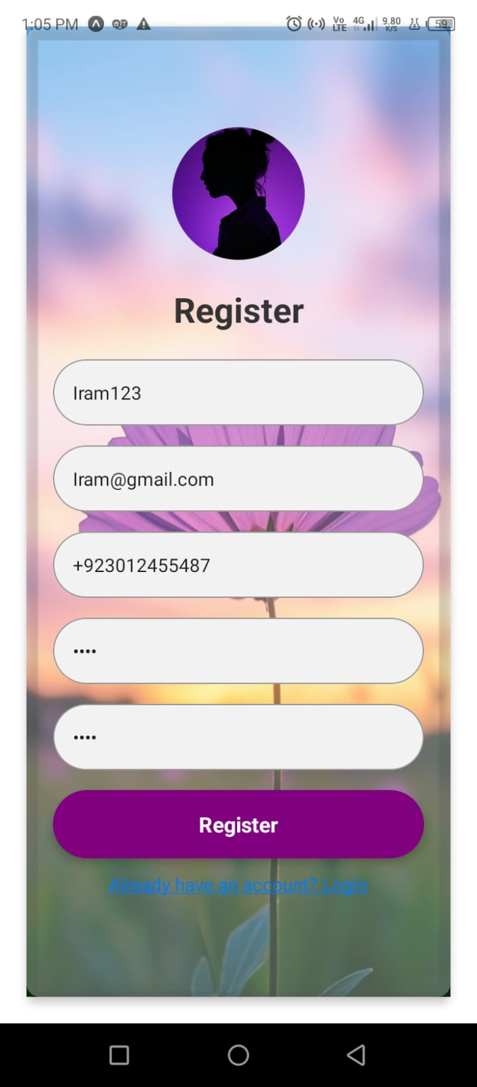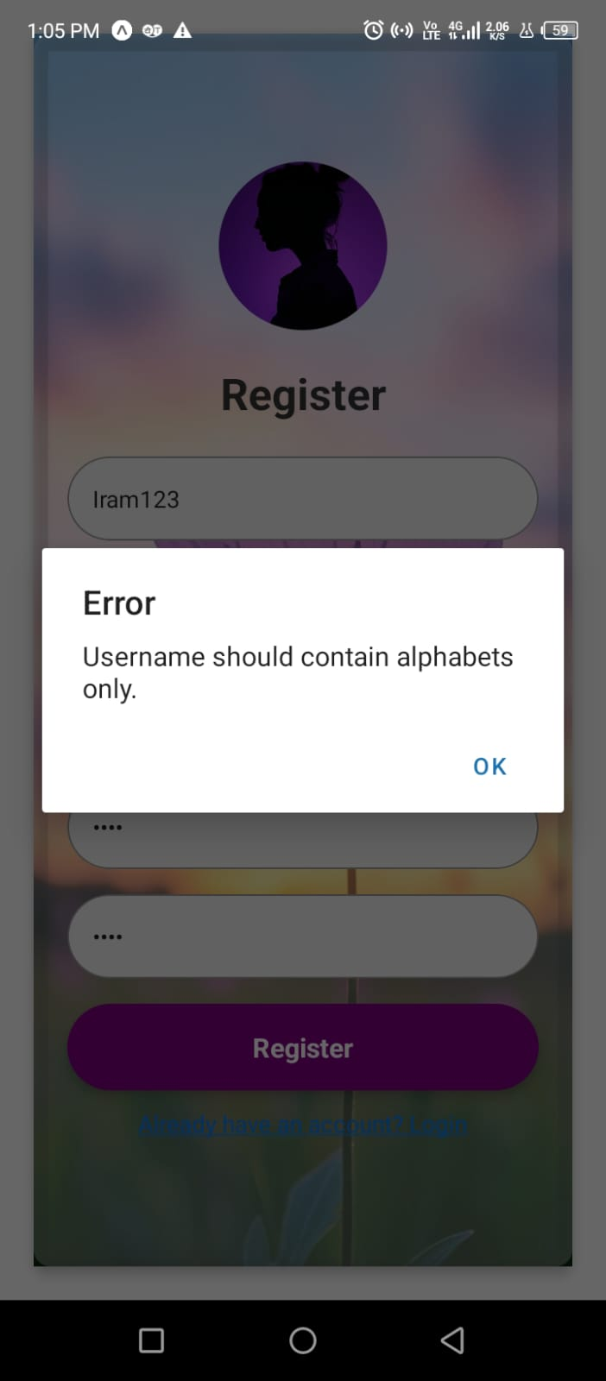
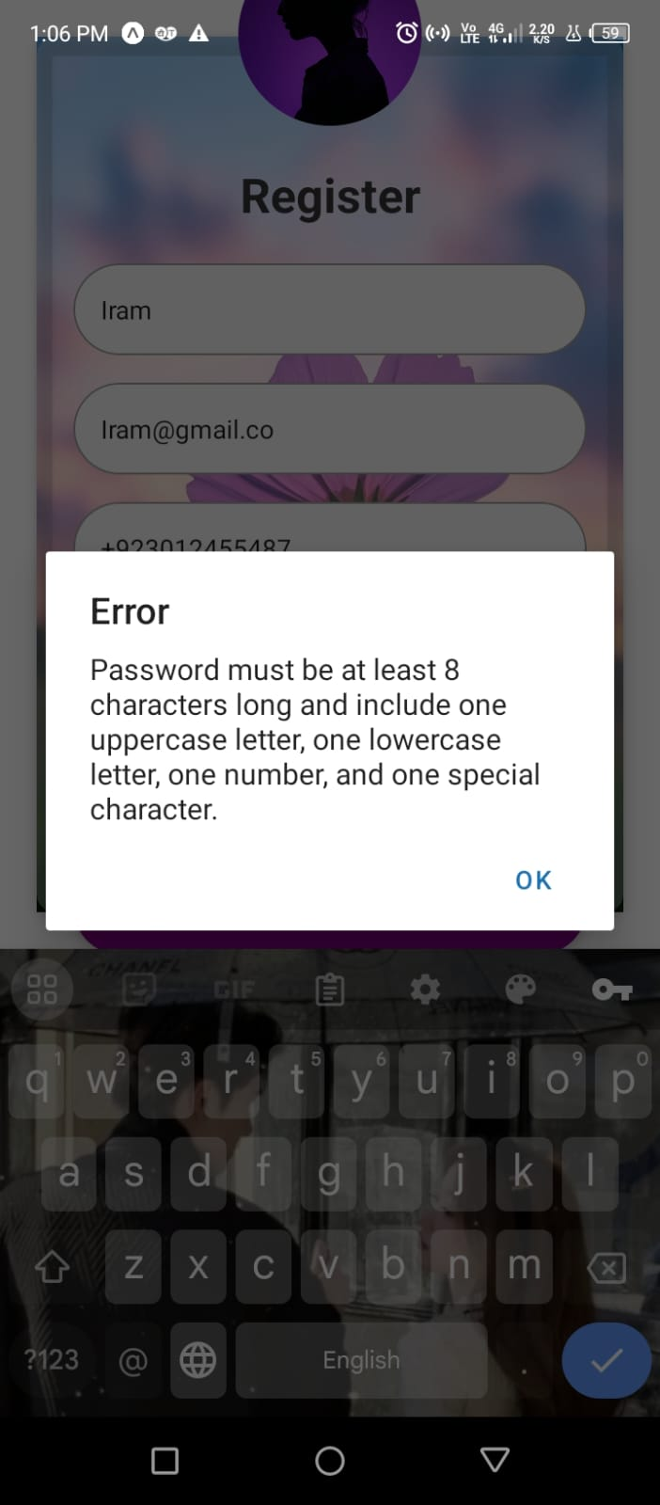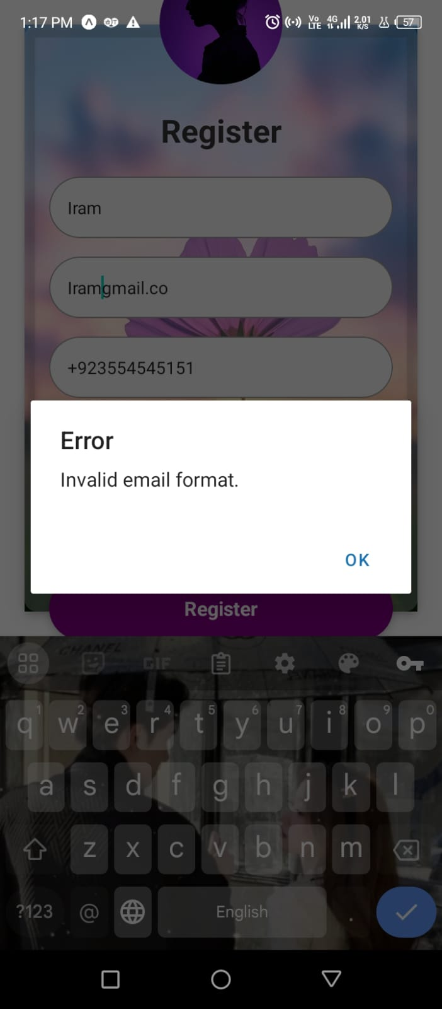
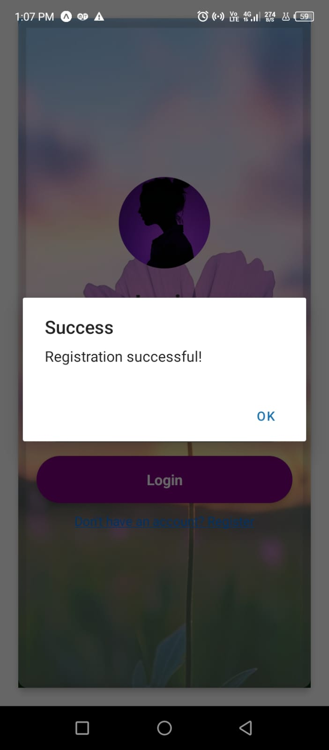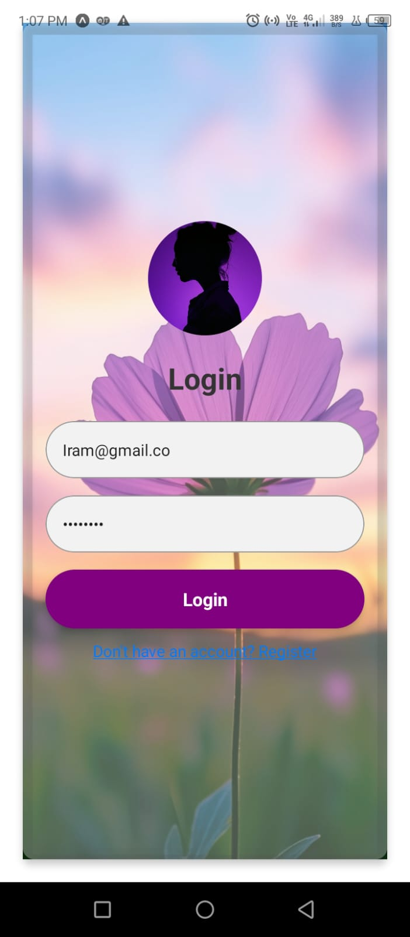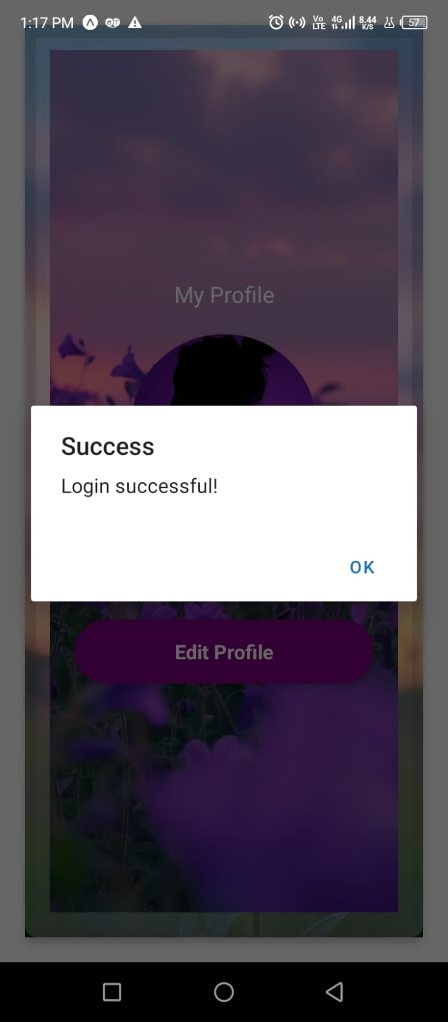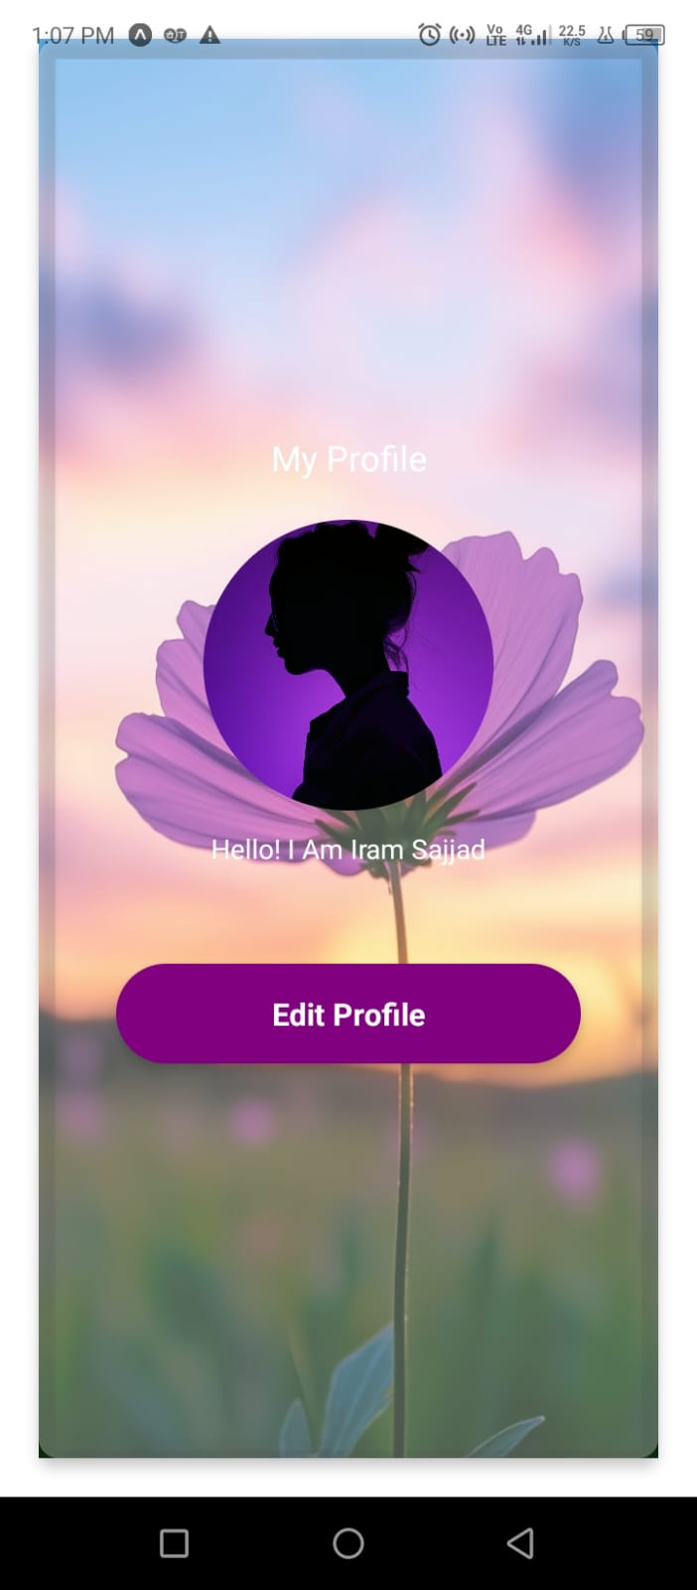
CODE:
import React, { useState } from 'react';
import { SafeAreaView, StyleSheet, View, TextInput, Text, TouchableOpacity, Alert, ImageBackground, Image } from 'react-native';
import * as SecureStore from 'expo-secure-store';

const App = () => {
const [screen, setScreen] = useState('login');
const [username, setUsername] = useState('');
const [email, setEmail] = useState('');
const [password, setPassword] = useState('');
const [confirmPassword, setConfirmPassword] = useState('');
const [phone, setPhone] = useState('');

// Registration validation
const handleRegistration = async () => {
// Username validation: Alphabets only
const usernameRegex = /^[A-Za-z]+$/;
if (!usernameRegex.test(username)) {
Alert.alert('Error', 'Username should contain alphabets only.');
return;
}

// Email validation
const emailRegex = /^[^\s@]+@[^\s@]+\.[^\s@]+$/;
if (!emailRegex.test(email)) {
Alert.alert('Error', 'Invalid email format.');
return;
}

// Password strength validation
const passwordRegex = /^(?=.*[a-z])(?=.*[A-Z])(?=.*\d)(?=.*[@$!%*?&])[A-Za-z\d@$!%*?&]{8,}$/;
if (!passwordRegex.test(password)) {
Alert.alert(
'Error',
'Password must be at least 8 characters long and include one uppercase letter, one lowercase letter, one number, and one special character.'
);
return;
}

// Confirm password check
if (password !== confirmPassword) {
Alert.alert('Error', 'Passwords do not match.');
return;
}

try {
const userData = { username, email, password, phone };
await SecureStore.setItemAsync('user', JSON.stringify(userData));
Alert.alert('Success', 'Registration successful!');
setScreen('login'); // Switch to login screen
} catch (error) {
Alert.alert('Error', 'Failed to save data.');
}
};

// Phone number validation
const handlePhoneChange = (input) => {
// Ensure the phone number always starts with +923
const fixedPrefix = "+923";
const remainingDigits = input.replace(fixedPrefix, ""); // Strip the prefix if present

// Allow only digits for the remaining part
const sanitizedInput = remainingDigits.replace(/\D/g, ""); // Remove non-digit characters

// Combine the fixed prefix with the sanitized digits
const fullPhoneNumber = fixedPrefix + sanitizedInput;

// Limit the length to the required format: +923XXXXXXXXX (13 characters total)
if (fullPhoneNumber.length <= 13) {
setPhone(fullPhoneNumber); // Update state
}
};

// Login validation
const handleLogin = async () => {
try {
const storedData = await SecureStore.getItemAsync('user');
const user = storedData ? JSON.parse(storedData) : null;

if (user && user.email === email && user.password === password) {
Alert.alert('Success', 'Login successful!');
setScreen('welcome'); // Navigate to the welcome screen after login
} else {
Alert.alert('Error', 'Incorrect email or password.');
}
} catch (error) {
Alert.alert('Error', 'Failed to fetch data.');
}
};

return (
<SafeAreaView style={styles.container}>
<ImageBackground
source={{ uri: 'https://snack-code-uploads.s3.us-west-1.amazonaws.com/~asset/d73e9c4575032bd5743a7c01f121cf9f' }}
style={styles.backgroundImage}
>
<View style={styles.innerContainer}>
{screen === 'register' && (
<>
<Image
source={{ uri: 'https://snack-code-uploads.s3.us-west-1.amazonaws.com/~asset/f18b9f3c12cf2ee33674402c466ff3ea' }}
style={styles.roundedImage}
/>
<Text style={styles.titleText}>Register</Text>
<TextInput
placeholder="Username"
value={username}
onChangeText={setUsername}
style={styles.input}
/>
<TextInput
placeholder="Email"
value={email}
onChangeText={setEmail}
keyboardType="email-address"
style={styles.input}
/>
<TextInput
placeholder="Phone Number"
value={phone}
onChangeText={handlePhoneChange}
keyboardType="phone-pad"
style={styles.input}
/>
<TextInput
placeholder="Password"
value={password}
onChangeText={setPassword}
secureTextEntry
style={styles.input}
/>
<TextInput
placeholder="Confirm Password"
value={confirmPassword}
onChangeText={setConfirmPassword}
secureTextEntry
style={styles.input}
/>
<TouchableOpacity onPress={handleRegistration} style={styles.button}>
<Text style={styles.buttonText}>Register</Text>
</TouchableOpacity>
<TouchableOpacity onPress={() => setScreen('login')} style={styles.switchButton}>
<Text style={styles.switchButtonText}>Already have an account? Login</Text>
</TouchableOpacity>
</>
)}

{screen === 'login' && (
<>
<Image
source={{ uri: 'https://snack-code-uploads.s3.us-west-1.amazonaws.com/~asset/f18b9f3c12cf2ee33674402c466ff3ea' }}
style={styles.roundedImage}
/>
<Text style={styles.titleText}>Login</Text>
<TextInput
placeholder="Email"
value={email}
onChangeText={setEmail}
keyboardType="email-address"
style={styles.input}
/>
<TextInput
placeholder="Password"
value={password}
onChangeText={setPassword}
secureTextEntry
style={styles.input}
/>
<TouchableOpacity onPress={handleLogin} style={styles.button}>
<Text style={styles.buttonText}>Login</Text>
</TouchableOpacity>
<TouchableOpacity onPress={() => setScreen('register')} style={styles.switchButton}>
<Text style={styles.switchButtonText}>Don't have an account? Register</Text>
</TouchableOpacity>
</>
)}

{screen === 'welcome' && (
<ImageBackground
source={{ uri: 'https://snack-code-uploads.s3.us-west-1.amazonaws.com/~asset/4e1cad4730346f62fb8e4ac423ed8c92' }}
style={styles.container}
>
<Text style={styles.text1}>My Profile</Text>
<View style={styles.pictureContainer}>
<Image
source={{ uri: 'https://snack-code-uploads.s3.us-west-1.amazonaws.com/~asset/f18b9f3c12cf2ee33674402c466ff3ea' }}
style={styles.picture}
/>
<Text style={styles.description}>Hello! I Am Iram Sajjad</Text>
</View>
<TouchableOpacity
style={styles.button}
onPress={() => Alert.alert('Profile Action', 'This could navigate elsewhere')}
>
<Text style={styles.buttonText}>Edit Profile</Text>
</TouchableOpacity>
</ImageBackground>
)}
</View>
</ImageBackground>
</SafeAreaView>
);
};
const styles = StyleSheet.create({
container: {
flex: 1,
justifyContent: 'center',
padding: 20,
},
backgroundImage: {
flex: 1,
justifyContent: 'center',
},
innerContainer: {
flex: 1,
justifyContent: 'center',
borderRadius: 10,
padding: 20,
backgroundColor: 'rgba(255, 255, 255,0.3)',
shadowColor: '#000',
shadowOffset: { width: 0, height: 2 },
shadowOpacity: 0.9,
shadowRadius: 4,
elevation: 5,
},
titleText: {
fontSize: 26,
fontWeight: 'bold',
textAlign: 'center',
marginBottom: 20,
color: '#333',
},
welcomeText: {
fontSize: 30,
fontWeight: 'bold',
textAlign: 'center',
marginBottom: 20,
color: '#333',
},
input: {
height: 50,
borderColor: '#999',
borderWidth: 1,
marginBottom: 15,
paddingHorizontal: 15,
borderRadius: 50,
backgroundColor: '#f2f2f2',
},
button: {
backgroundColor: 'purple',
padding: 15,
borderRadius: 50,
marginBottom: 15,
alignItems: 'center',
elevation: 3,
},
buttonText: {
color: 'white',
fontWeight: 'bold',
fontSize: 16,
},
switchButton: {
alignItems: 'center',
marginTop: 10, },
switchButtonText: {
color: '#007bff',
textDecorationLine: 'underline',
fontSize: 14, },
roundedImage: {
width: 100,
height: 100,
borderRadius: 50,
marginBottom: 20,
alignSelf: 'center',
},
text1: {
fontSize: 18,
marginBottom: 20,
color: 'white',
textAlign: 'center',
},
pictureContainer: {
alignItems: 'center',
marginBottom: 30,
},
picture: {
width: 150,
height: 150,
borderRadius: 75,
marginBottom: 10,
},
description: {
fontSize: 14,
color: 'black',
textAlign: 'center',
marginBottom: 20,
color: 'white',
},
button: {
paddingVertical: 15,
paddingHorizontal: 30,
borderRadius: 50,
alignItems: 'center',
justifyContent: 'center',
backgroundColor: 'purple',
shadowColor: '#000',
shadowOffset: { width: 0, height: 2 },
shadowOpacity: 0.3,
shadowRadius: 3,
elevation: 5,
},
buttonText: {
fontSize: 16,
fontWeight: 'bold',
color: 'white',
},

}); export default App;

